**Experiment 4**

**PD LAB**

**Name: Veeransh Shah**

**Reg No.: 221070063**

**SY BTech - CE**

Write a Contact application

**Code:**

contact_book = {}

while True:

choice = input("Please enter [A/S/P/X]\nA - All numbers\nS - Save Contact\nP - Display Contact\nX - Exit").upper()

if choice == 'S':

name = input("Enter the name: ")

number = input("Enter the contact number: ")

email = input("Enter the email id: ")

company = input("Enter your company: ")

# Store the contact information as a dictionary within the contact_book

contact_book[name] = {

'Number': number,

'Email': email,

'Company': company

}

elif choice == 'P':

search = input("Enter the name: ")

# Check if the name exists in the contact book

if search in contact_book:

contact_info = contact_book[search]

i = input("Please enter any one [NO/E/C]\nNO - Number\nE - Email id\nC - Company").upper()

if i == 'NO':

print(f"The number of {search} is: {contact_info['Number']}")

elif i == 'E':

print(f"The email id of {search} is: {contact_info['Email']}")

elif i == 'C':

print(f"The company of {search} is: {contact_info['Company']}")

# else:

# print(f"{search} is not in the contact book.")

elif choice == 'A':

# Print the entire contact book

print(contact_book)

elif choice == 'X':

break

Output:

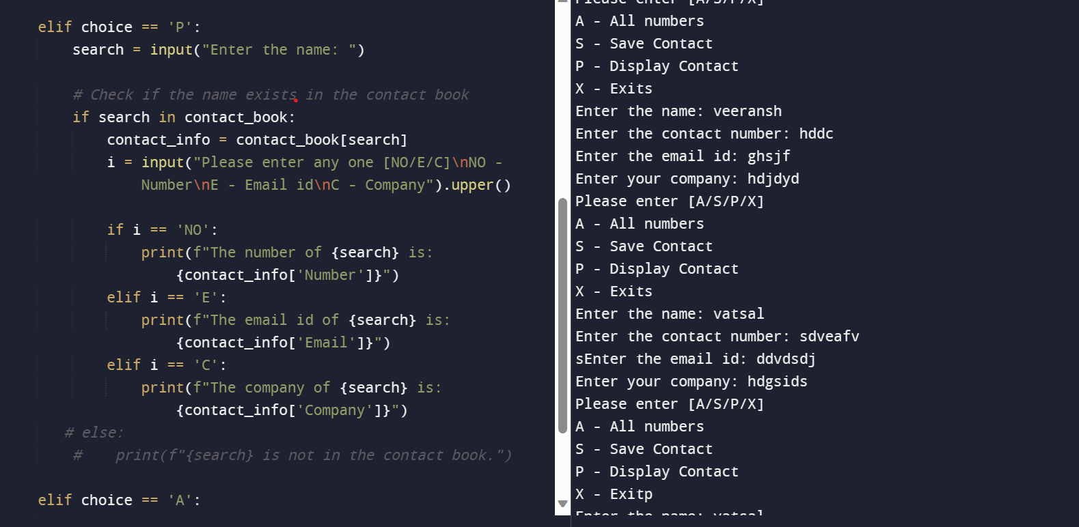

**Conclusion:**

Through this assignment we learn how to make dictionaries to ease human tasks. We learn to make the same in python which has various libraries.